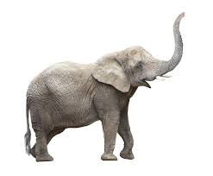
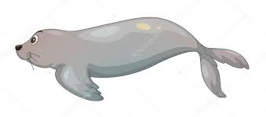
F F

F F F F F F F F F F F F
F F F F F F F F F F F F
F F F F F F F F F F F F
F F F F F F F F F F F F
F F F F F F F F F F F F
F F F F F F F F F F F F
F F F F F F F F F F F F

