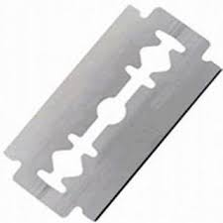
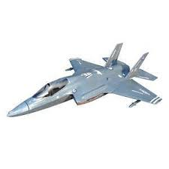
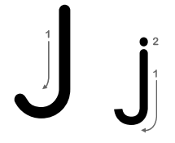
J j J j J j J j J j J j J J j J j J j J j J j J j J
J j J j J j J j J j J j J
J j J j J j J j J j J j J
J j J j J j J j J j J j J
J j J j J j J j J j J j J
J j J j J j J j J j J j J
J j J j J j J j J j J j J

