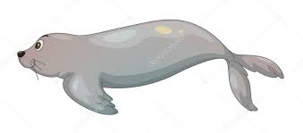
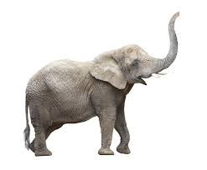
F f

F f F f F f F f F f F f
F f F f F f F f F f F f
F f F f F f F f F f F f
F f F f F f F f F f F f
F f F f F f F f F f F f
F f F f F f F f F f F f
F f F f F f F f F f F f

